**INV No.: JMA/BML/1806/25**

**INV Date: 18th June, 2025**

**INV Due Date: 18th June 2025**

**To:** **Boresha Maisha Micro LTD**

**Kinango - Kwale, Kenya.**

**Tel** +254 746 769597

**Email:** hamzamuriphe@gmail.com

**From: Jafari Mchasa Akida**

Founder & CEO,

TuCode Tech Solutions.

**Ramisi - Kwale, Kenya.**

**Tel** +254 759 184063

Email: [JMchfundi@gmail.com](mailto:JMchfundi@gmail.com)

|  |  |  |  |  |
| --- | --- | --- | --- | --- |
| **Item** | **Description** | **Amount in USD** | **Amount in KES (Monthly)** | **Amount in KES (Item / Annual)** |
| 1 | TRES - finsis (boresha maisha ERP) (one time) | - | Ksh. 150,000.00 | Ksh. 150,000.00 |
| 2 | Flexible Server Deployment, Burstable Tier, 1 B1MS (1 vCores) x 1 Month, 5 GB Storage with ZRS redundancy, 0 million Paid IO, 20 GB Additional Backup storage with LRS | $14.89 | Ksh. 2,009.48 | Ksh. 24,113.70 |
| 3 | Azure Support | $5.00 | Ksh. 675.00 | Ksh. 8,100.00 |
|  |  |  |  |  |
| **Total** | | | **Ksh. 152,684.48** | **Ksh. 182,213.70** |
|  |  |  |  |  |
| discount (TRES - finsis (boresha maisha ERP)) | | | 33% | Ksh. 50,000.00 |
|  |  |  |  |  |
| payable | | | | Ksh. 132,213.70 |

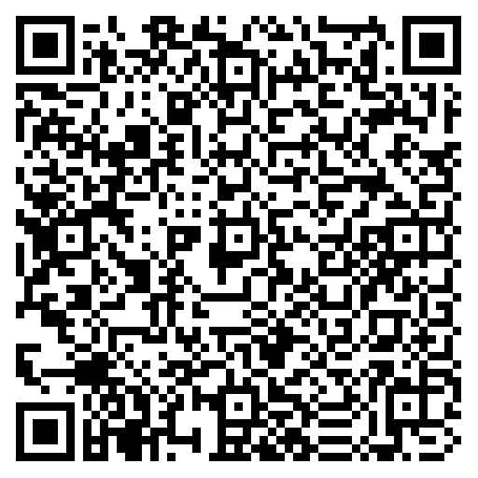

Scan me to pay

0759184063

**I&M Bank**

**Patel Samaj Building**

**Ground Floor**

**Haile Selassie Avenue**

**P.O Box 86357 – 80100**

**Mombasa, Kenya**

|  |  |  |
| --- | --- | --- |
| **A/C NAME: JAFARI MCHASA AKIDA** | **OR** | **LIPA NA MPESA** |
| **A/C NO: KES 04303789286150** |  | **PAYBILL: 542542** |
| **Bank Name: I&M** |  | **A/C NO: 230592** |
| **Branch Name: HAILE SELASSIE** | **A/C NAME: JAFARI MCHASA AKIDA** | |
| **Bank Code: 57** |  | |
| **Branch Code: 043** |  | |
| **Swift Code: IMBLKENA** |  | |

**Contact Me: Phone:** +254 759 184063 **Email: JMchfundi@gmail.com**

[**TuCode Tech Solutions - Solutions We Can Trust**](https://www.tucode.co.ke/)